**********************************************************************

INSTALLATION AND CREATION OF MS SQL – SYBASE Connector

**********************************************************************

**Step i**

1. Install SYBASE Driver

**Step ii**

1. Create a data source using "**Sybase Configuration Manager**" on the Desktop of the installed syste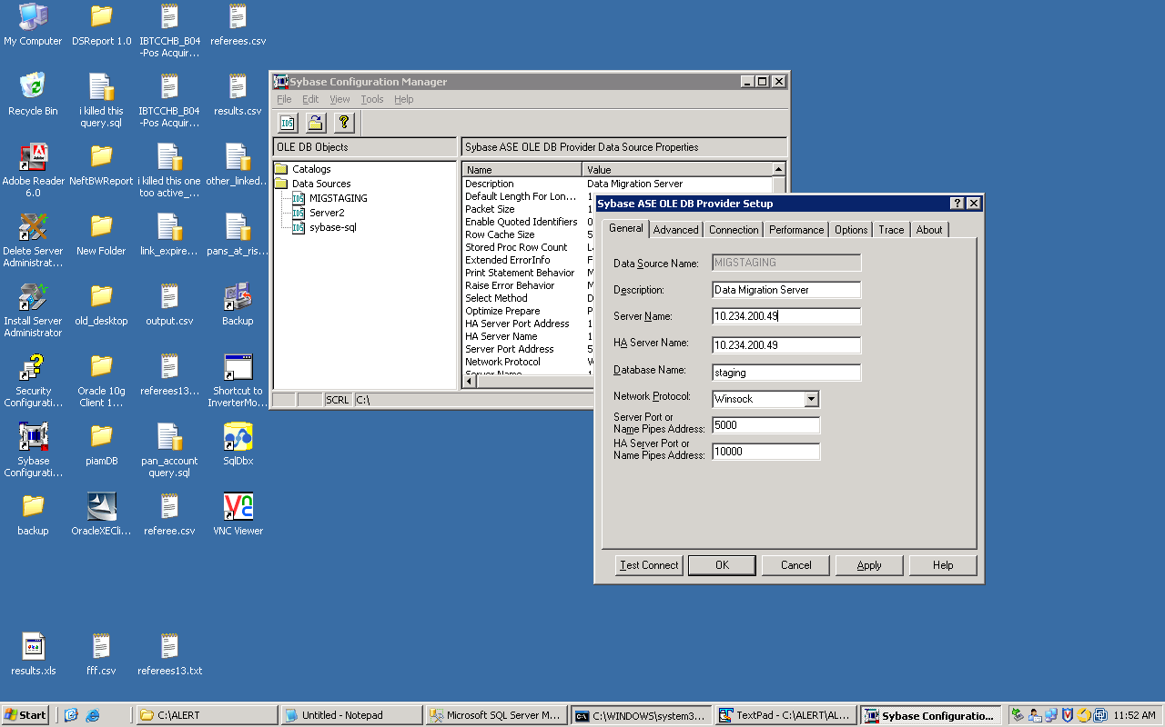

Example:

Data Source: MIGSTAGING

Server name: 10.234.200.49

Database name: Staging

Port: 500

Step 3:

1. Create the Database Link

* Open the Ms Sql Studio Express
* Click Server objects >> Linked Servers
* 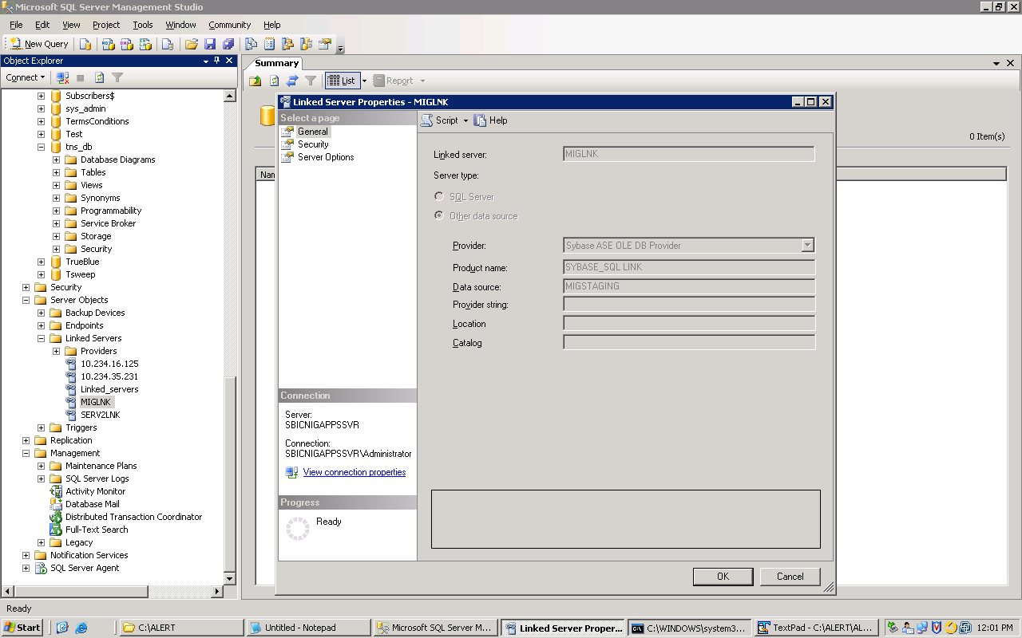

Example:

Linked Server name: MIGLNK

Provider: SYBASE_SQL link

Data Source: MIGSTAGING